

**Department of**

**Computer Science and Engineering**

**Lab Report - 04**

Course No.              : CSE-308

Course Title             : System Analysis and Design Laboratory

Submitted By         :

  Name : 1 . Tasmim Sultana(129)

  2 . Fatama Jannat Tisha (131)

                                   3 .  Kamelia Zaman Moon (299)

                               4  .Umma Salma (302)

                                   5 . Sabrina Afrin Toma (304)

         Session        : 2017-18

         Semester     : 3rd year 1st Semester

Date            : 19-07-2020

Submitted To:

Md Musfique Anwar

         Associate Professor, Department of Computer Science and Engineering

         Dr. Md Humayun Kabir

Professor, Department of Computer Science and Engineering

Jahangirnagar University, Savar

**Experiment No.:** 04

**Title:** Use Case Diagram & User Interface Design for Online Class & Examination System.

**Objective:** To create a use case diagram for selected project. Also to represent the user interface design of the project.

**Procedure:**

1. **Use Case Diagram:**
   1. We open a tool to create the use case diagram.
   2. We identify who the actors will be and their actions.
   3. We link between the actors and their actions.
   4. We add extend/include methods for the actions if needed.
   5. **Diagram:**

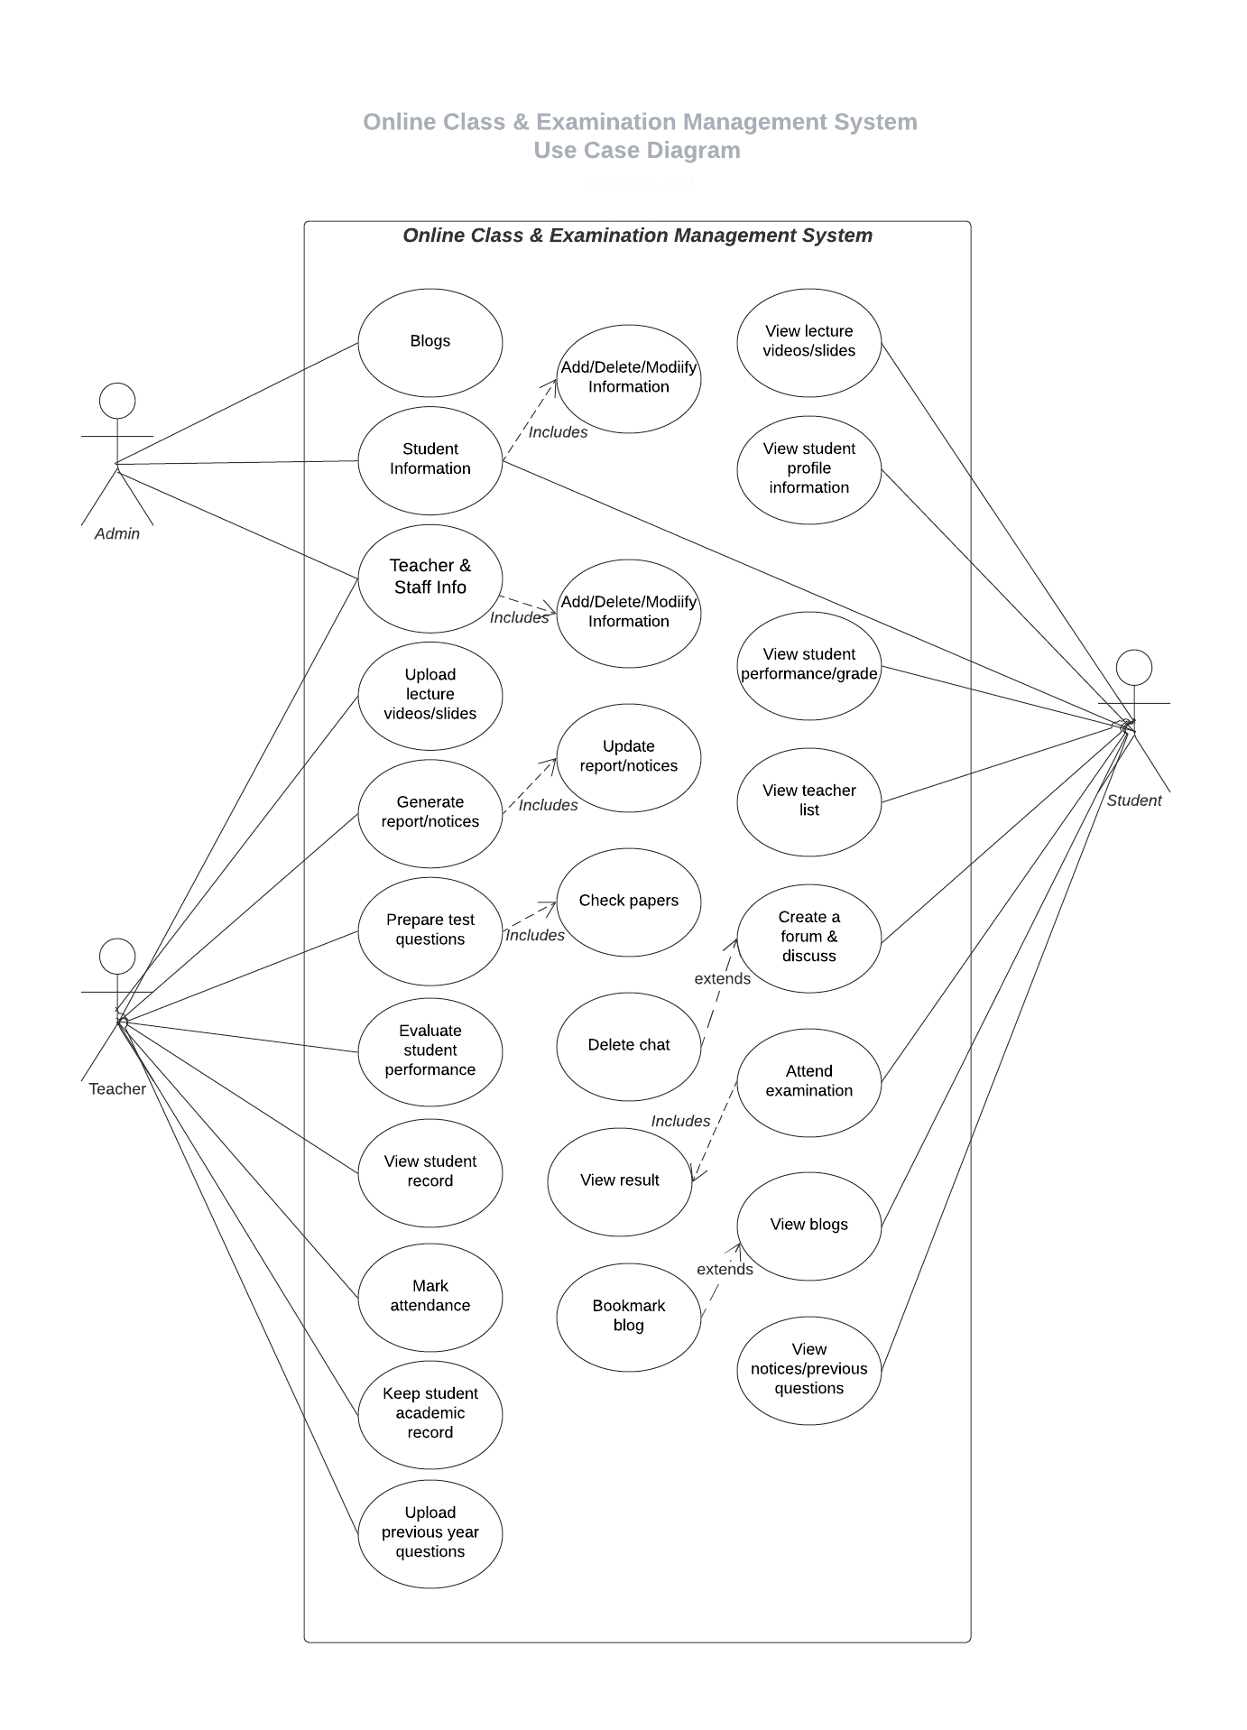

1. **User Interface Design:**
   1. We open a tool to create the user interface design.
   2. We create a home page.

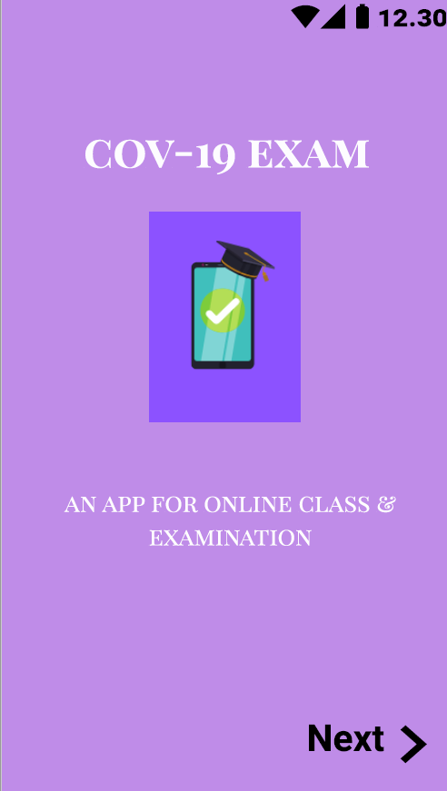

* 1. Then we add a login page for users to login and also create a new account.

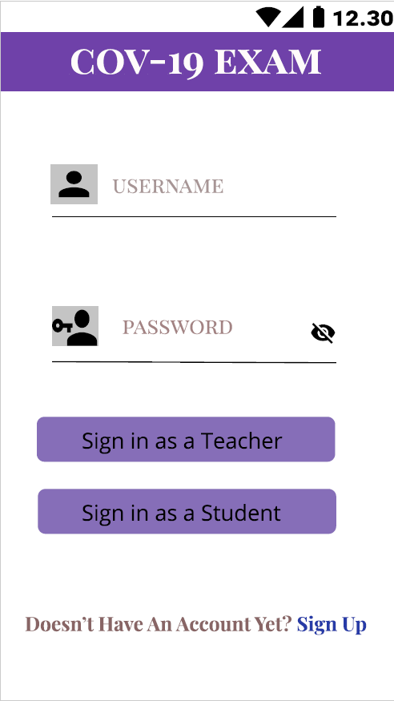

* 1. We create a signup page for the new users to create accounts.

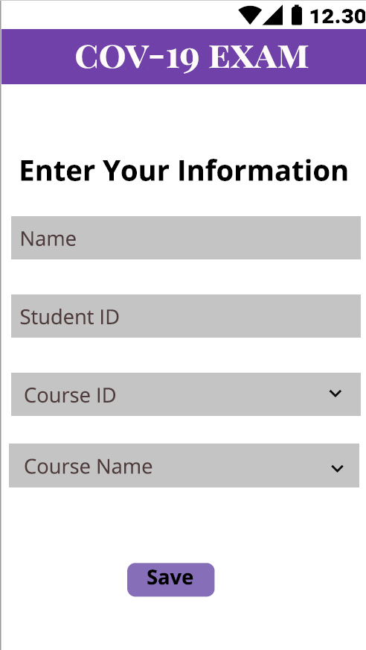

* 1. Adding a menu page for student view after logging in.

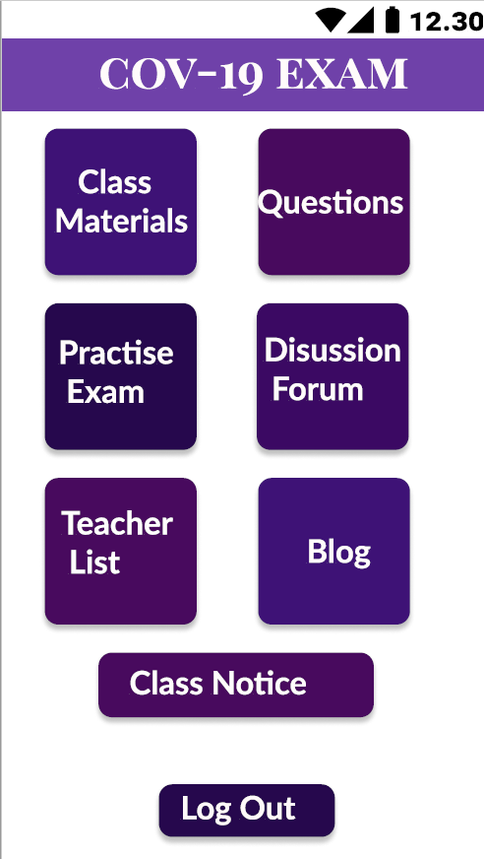

* 1. Adding Class Materials page menus for student view.

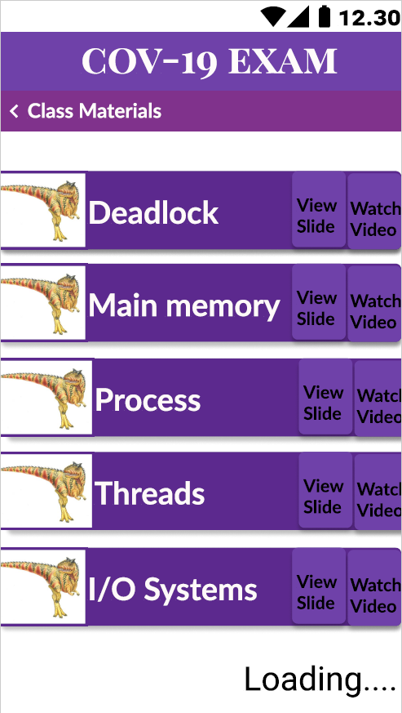

* 1. Creating View Slide page for student view.

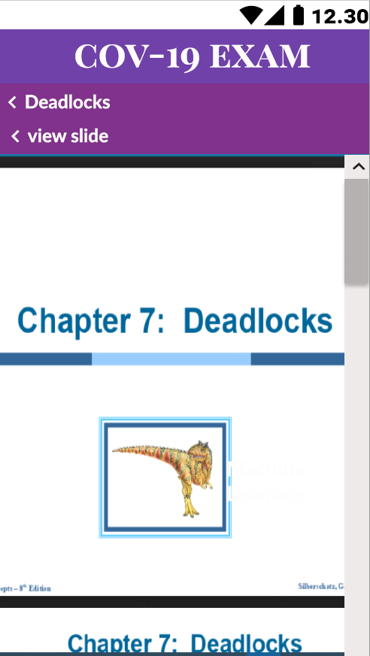

* 1. Adding Watch Video page for student view.

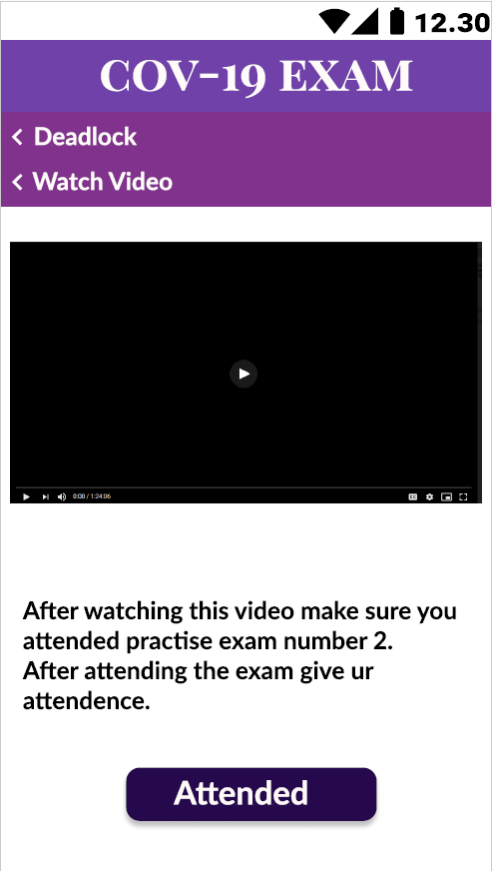

* 1. Next we add the Questions page menu for student view.

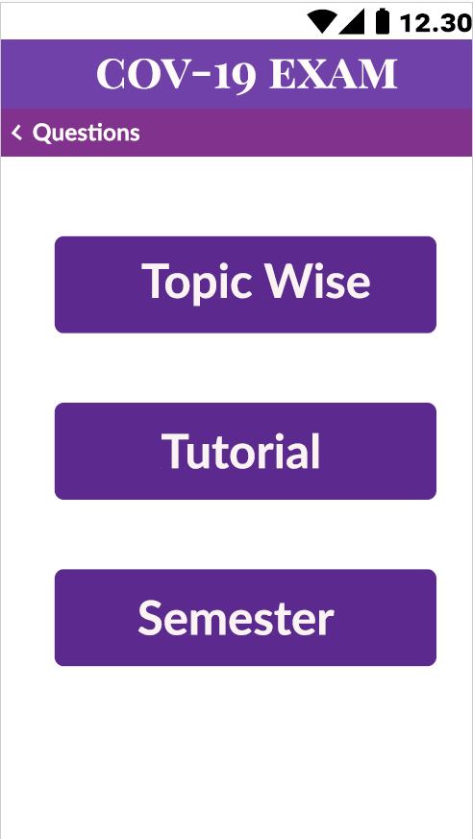

* 1. We create Topic Wise questions menus for student view.

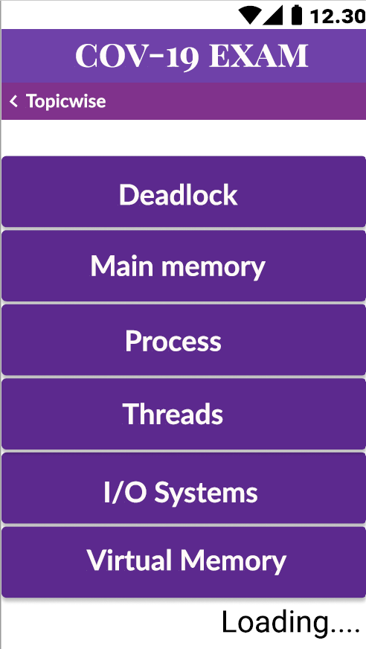

* 1. Creating Past Tutorial question menus for student view.

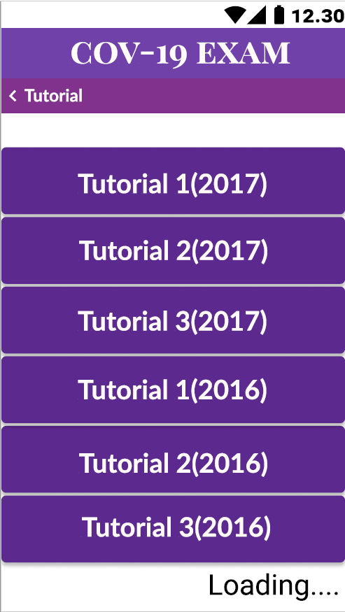

* 1. Creating Past Final question menus for student view.

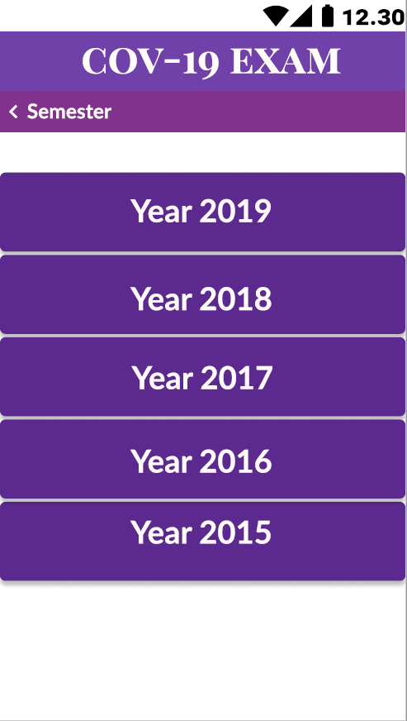

* 1. Then we design the Question view page under topic wise for student view.

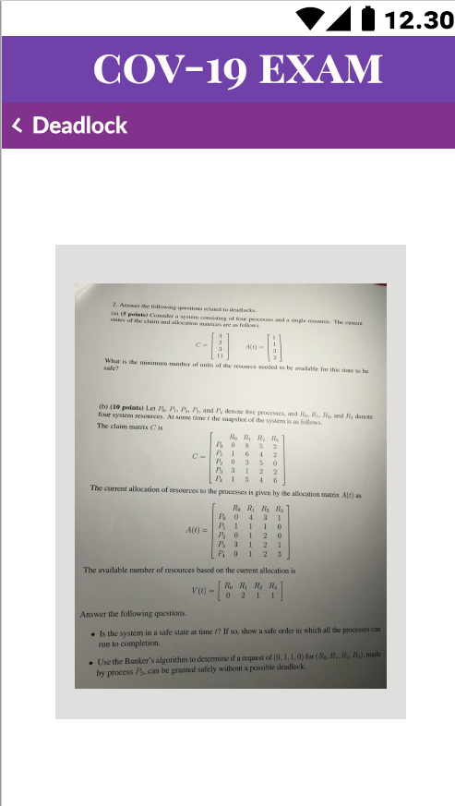

* 1. Next we design the Question view page from past tutorial questions for student view.

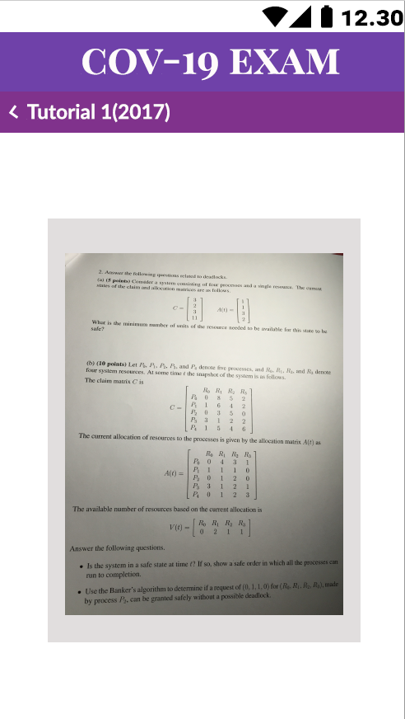

* 1. After that we design the Question view page from past final questions for student view.

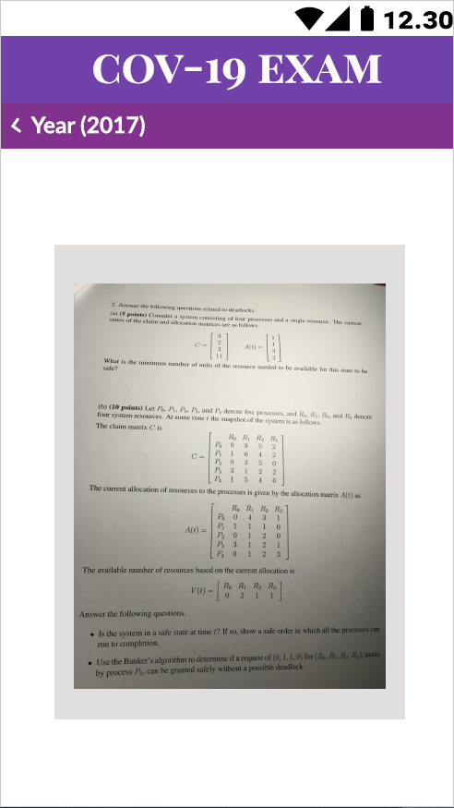

* 1. Adding Practise Exam menus for student view.

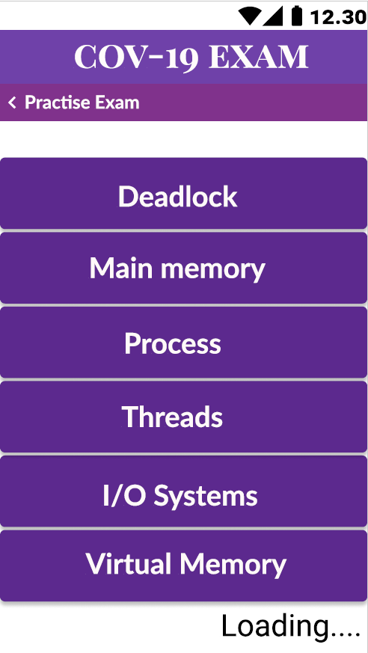

* 1. Adding practise exam questions and options for student view.

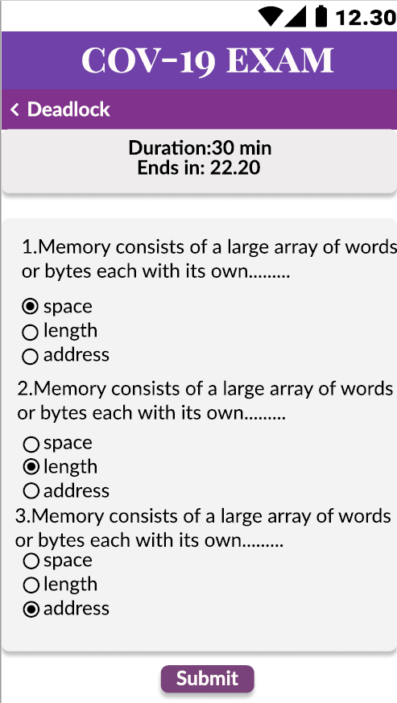

* 1. Adding solution page for practise exam with grade for student view.

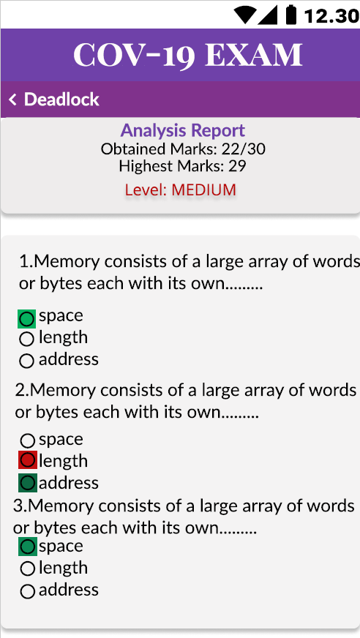

* 1. Now we create a discussion page for student view.

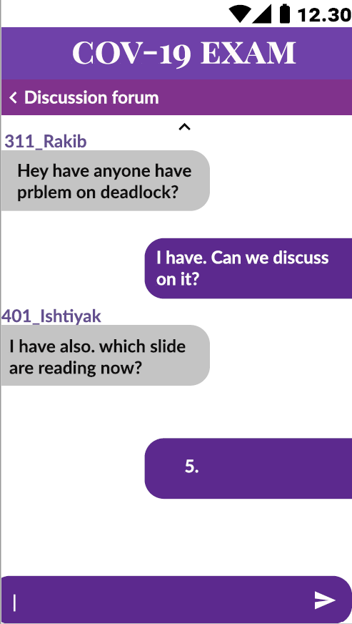

* 1. Next we design the Teacher List page for student view.

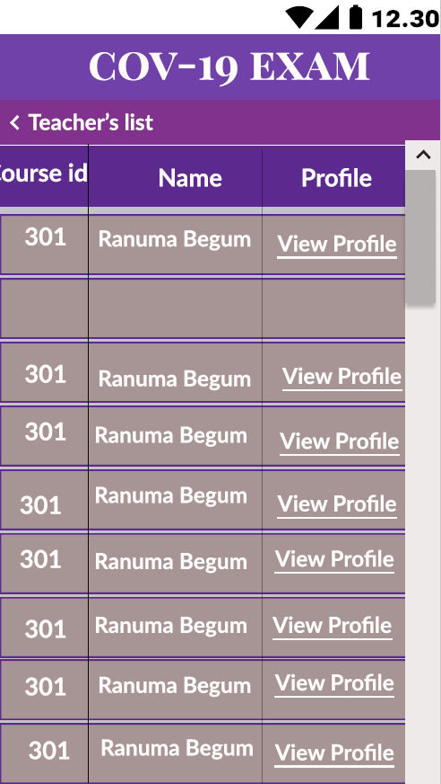

* 1. Then we add a profile page with teacher details for student view.

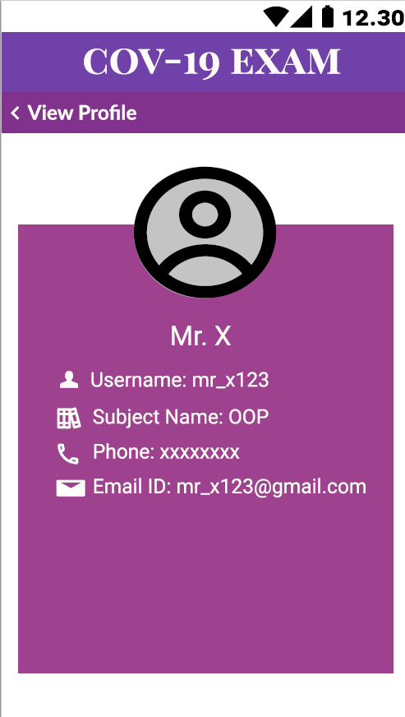

* 1. Creating a notice page for student view.

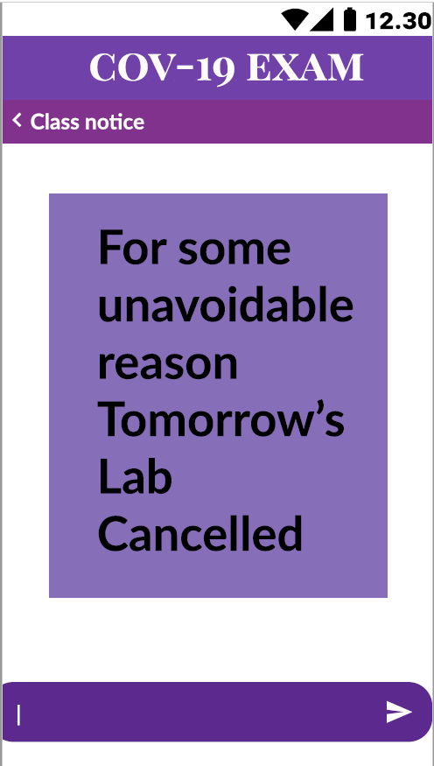

* 1. Adding blog menus for students to view.

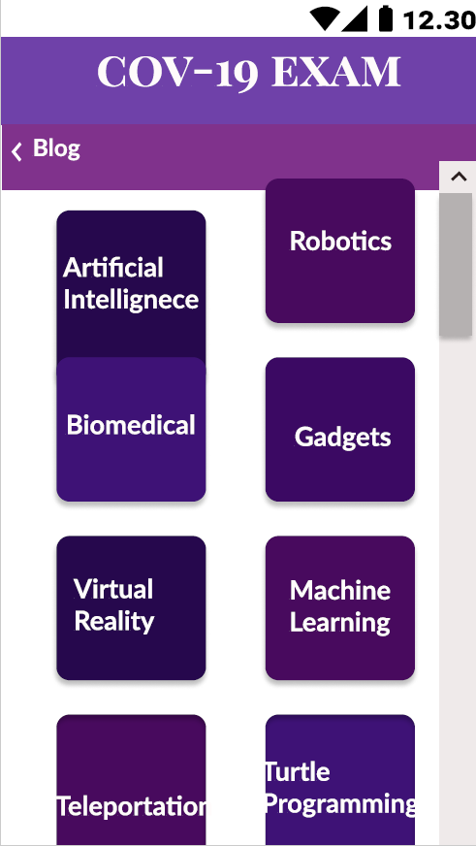

* 1. Adding a blog page for student view.

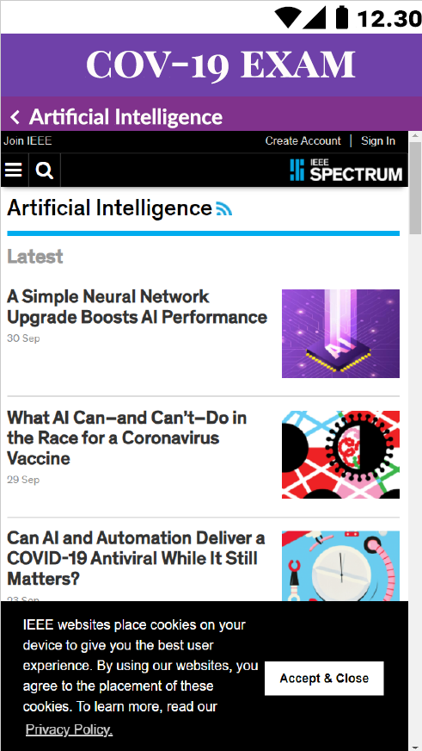

* 1. Adding a menu page for teacher view after logging in.

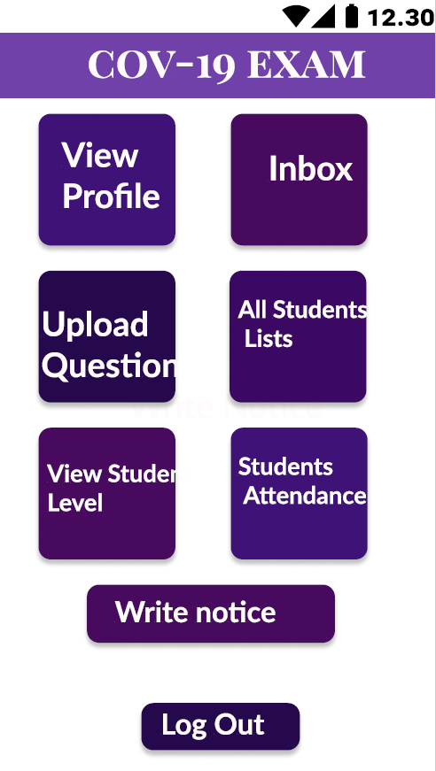

* 1. Now we design a profile page with teacher details for teacher view.

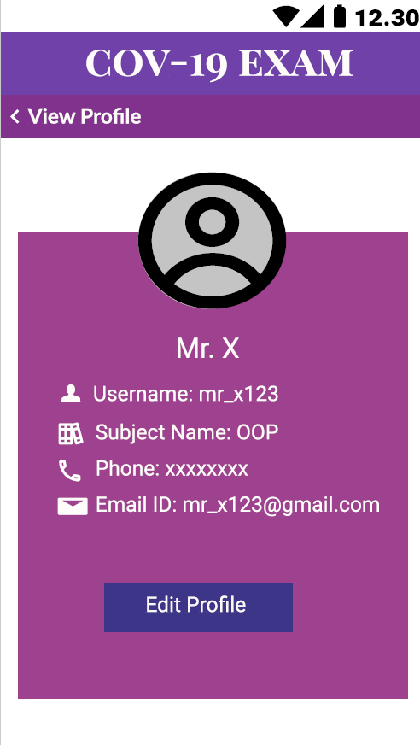

* 1. Adding an Inbox page for teachers.

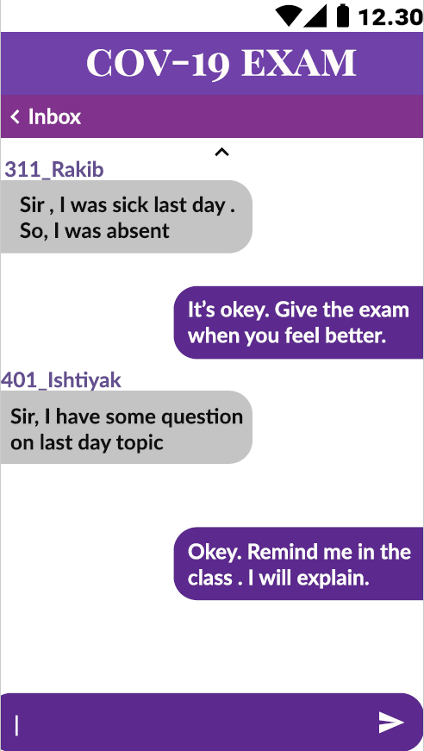

* 1. After that we add menus of Upload Questions for teacher view.

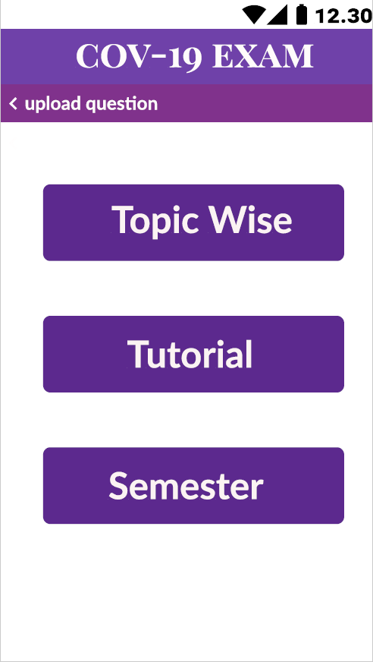

* 1. Designing Topic Wise question upload page for teach view.

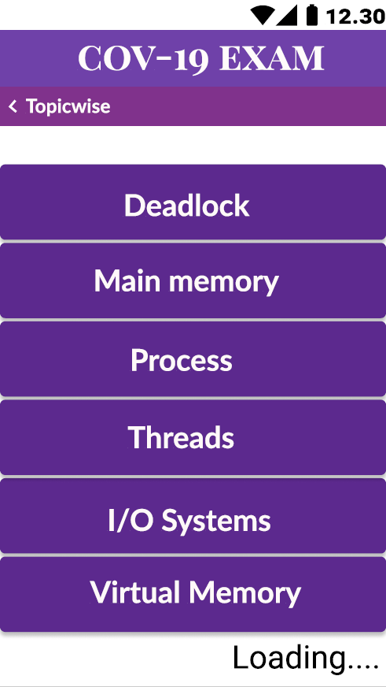

* 1. Creating the page for uploading questions for teacher view.

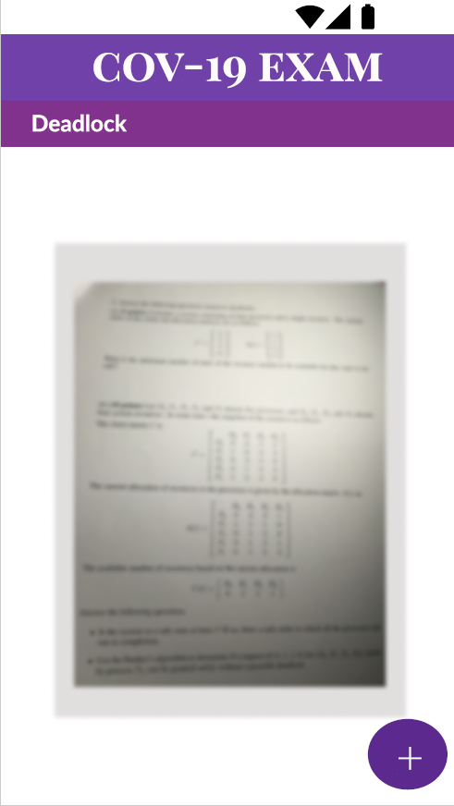

* 1. We add a student list with details for teacher view.

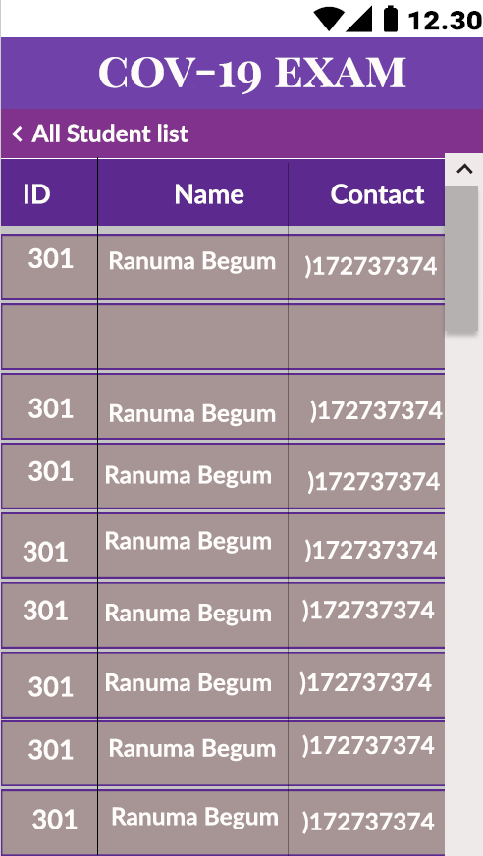

* 1. Creating student grading level page for teacher view.

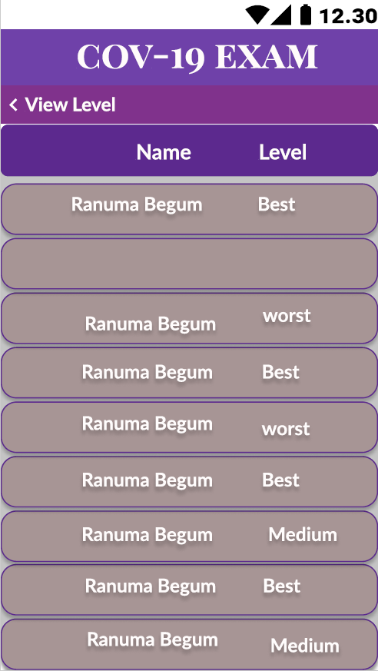

* 1. We add an Attendance page for teachers to view.

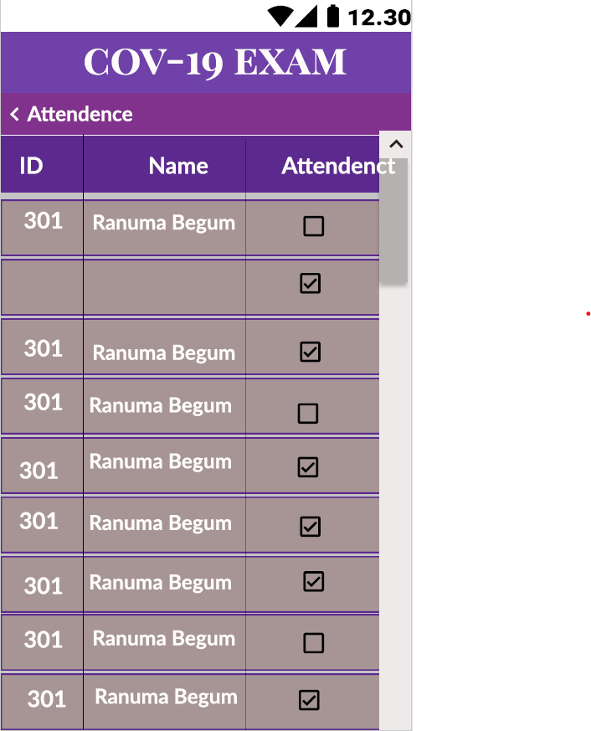

* 1. Now we design a notice uploading page for teacher view.

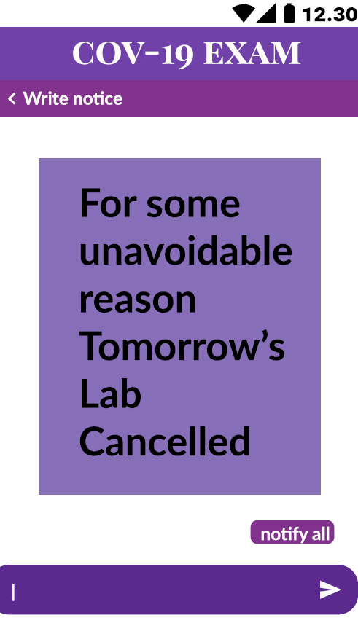

**Discussion:** From this project we got to learn about use case diagram and user interface design. Use case diagram only summarizes some of the relationships between use cases, actors and systems. It’s also the simplest picture of a user's interaction with the system. On the other hand, user interface design shows the output picture of a system meaning how the graphical interface will be displayed to the users.